Geography and Setting

**The World:**

**World Description**: Earth

**Location 1:** This should be the first stage, located in a park. The setting is a mainly tree-filled area with a fountain in the central area (see stage design document). The location has significance as being in the city where the Keepers of the Four are centered, as well as being at the center of the elemental chaos.

**Location 2: (TBD)**

Civilizations and History

**History/Backstory:** The world is Earth, it’s history being identical to that of reality with the minor difference of an existing religion that stems from the belief that the four elements (time, space, death, and life) are naturally chaotic in their own right and, by extension, must be kept under control.

**Present day:** The world is in the year 20(XX). The elements have escaped the control of the RELIGION and are causing worldwide damage. Randolph is only one of many followers that have gone out to wrest control of the elements to stem the chaos. Lynne, also a follower, has decided to use this problem to freely go into the world and use her powers of the elements to spread even more destruction.

Religion and Mythology

Keepers of the Four

**Section 1:**

* The followers of the religion are caretakers of the four elements, naturally chaotic and in need of being contained.

**Section 2:**

Icon Ideas

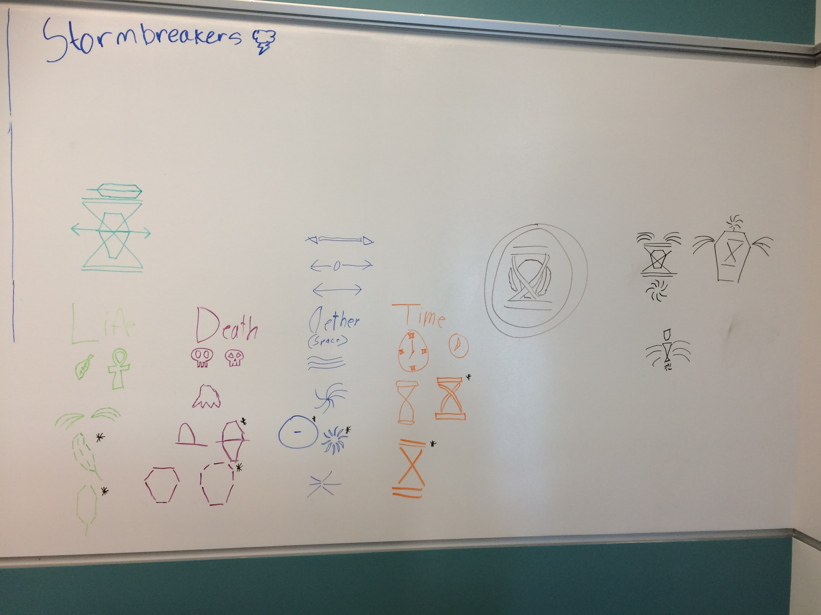 Life: A pair of wings, represented by curved lines sprawling out from the center

Death: A dead tree, the body of the tree would be deeper, but the branches can be represented by simple lines.

Space: A large circle with a small dash in the middle

Time: An X with two lines on the top and bottom, making an hourglass

Technology

**Basics of Technology:**

The plot takes place in a modern setting. The world functions adequately with modern technology such as cars, electricity, internet, etc.

Characters and Motivations

**Randolf**: Devout follower of RELIGION. His main goal is to keep the balance of the world by watching over the elements. Heads out to make sure that Lynne doesn’t go down the wrong path.

**Lynne**: Previously a follower of RELIGION, but disagreed with the motives and left. She now travels around, using the elements to test the limits of her control over them.